MS Planner Guide

In T2 2024, Chameleon migrated from Trello to Microsoft Planner for project management. This guide will help you to navigate and understand how to use MS Planner for the City of Melbourne project.

# What are buckets?

Buckets are used to organize and categorize tasks within a Planner to represent different phases or types of work. In our Melbourne City Planner, some of the most important buckets are: Backlog, Sprint-1, Sprint-2, Sprint-3, Ready for Review, Company Handover and Completed. Each bucket card represents specific tasks.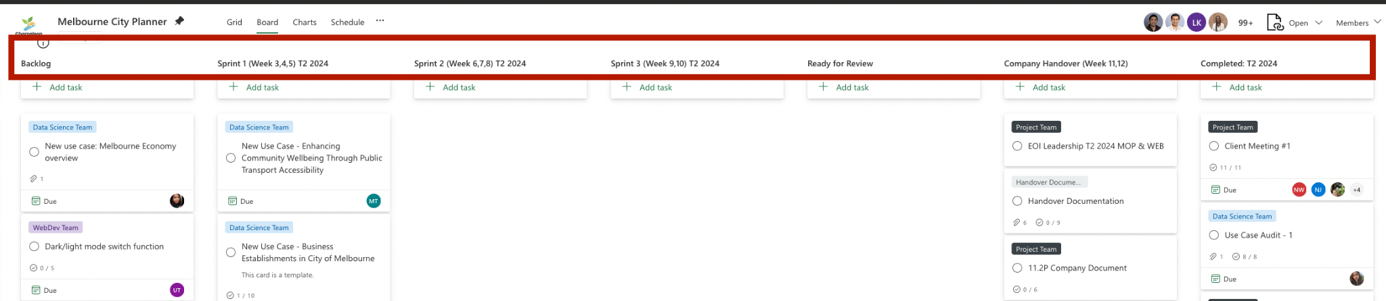

# How to make cards?

To create a new card simply move to “Templates and Project Information bucket” and select the template that’s relevant to your issue/task and click the three dots on the upper right side of the card and select "Copy Task". A pop up of the new card will allow you to rename the card, select the Planner, select the bucket and allow you to choose task information such as Description, Checklist, Attachments, Labels etc.

For example: To create a Data Science use case card:

* Go to Templates and Project Information and find Data Science Team Card (This card is a template). ***Do not modify or use the template cards themselves.***

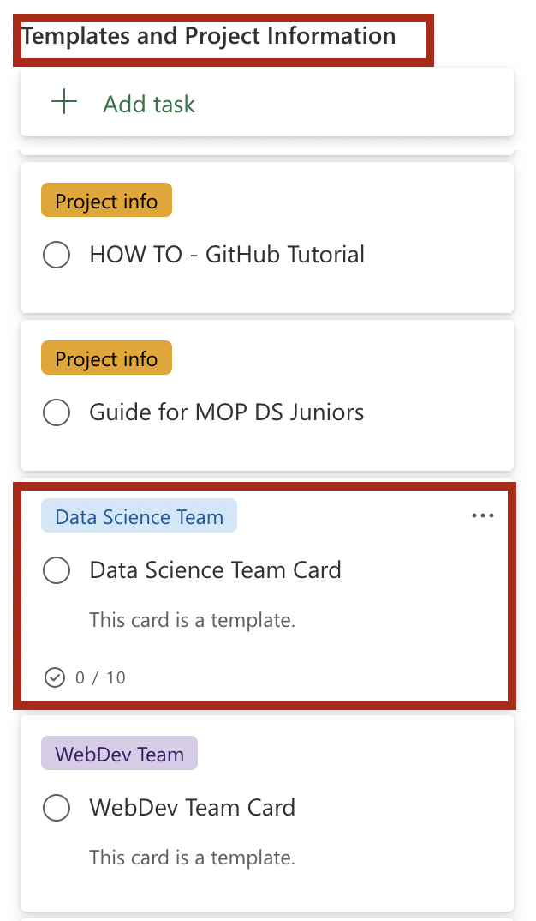

Click the 3 dots on the upper right side of the card and select “Copy task” from the drop down list.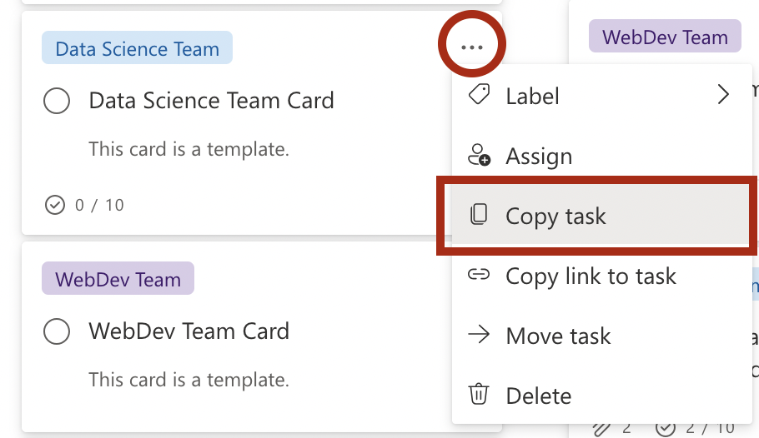

A pop-up card will appear, allowing you to modify the use case name, select the Planner and bucket it belongs to, and enter task information such as description, checklist, attachments, labels, and more. ***For Data Science Use Case the title must contain “New Use Case” if it is a new use case card, or “New API” if it is an API repointing card, followed by a “-” and the name of the use case.*** Put the card in the relevant bucket, for this example, I will put it in the Backlog and select Description, Checklist, Attachments and Labels.

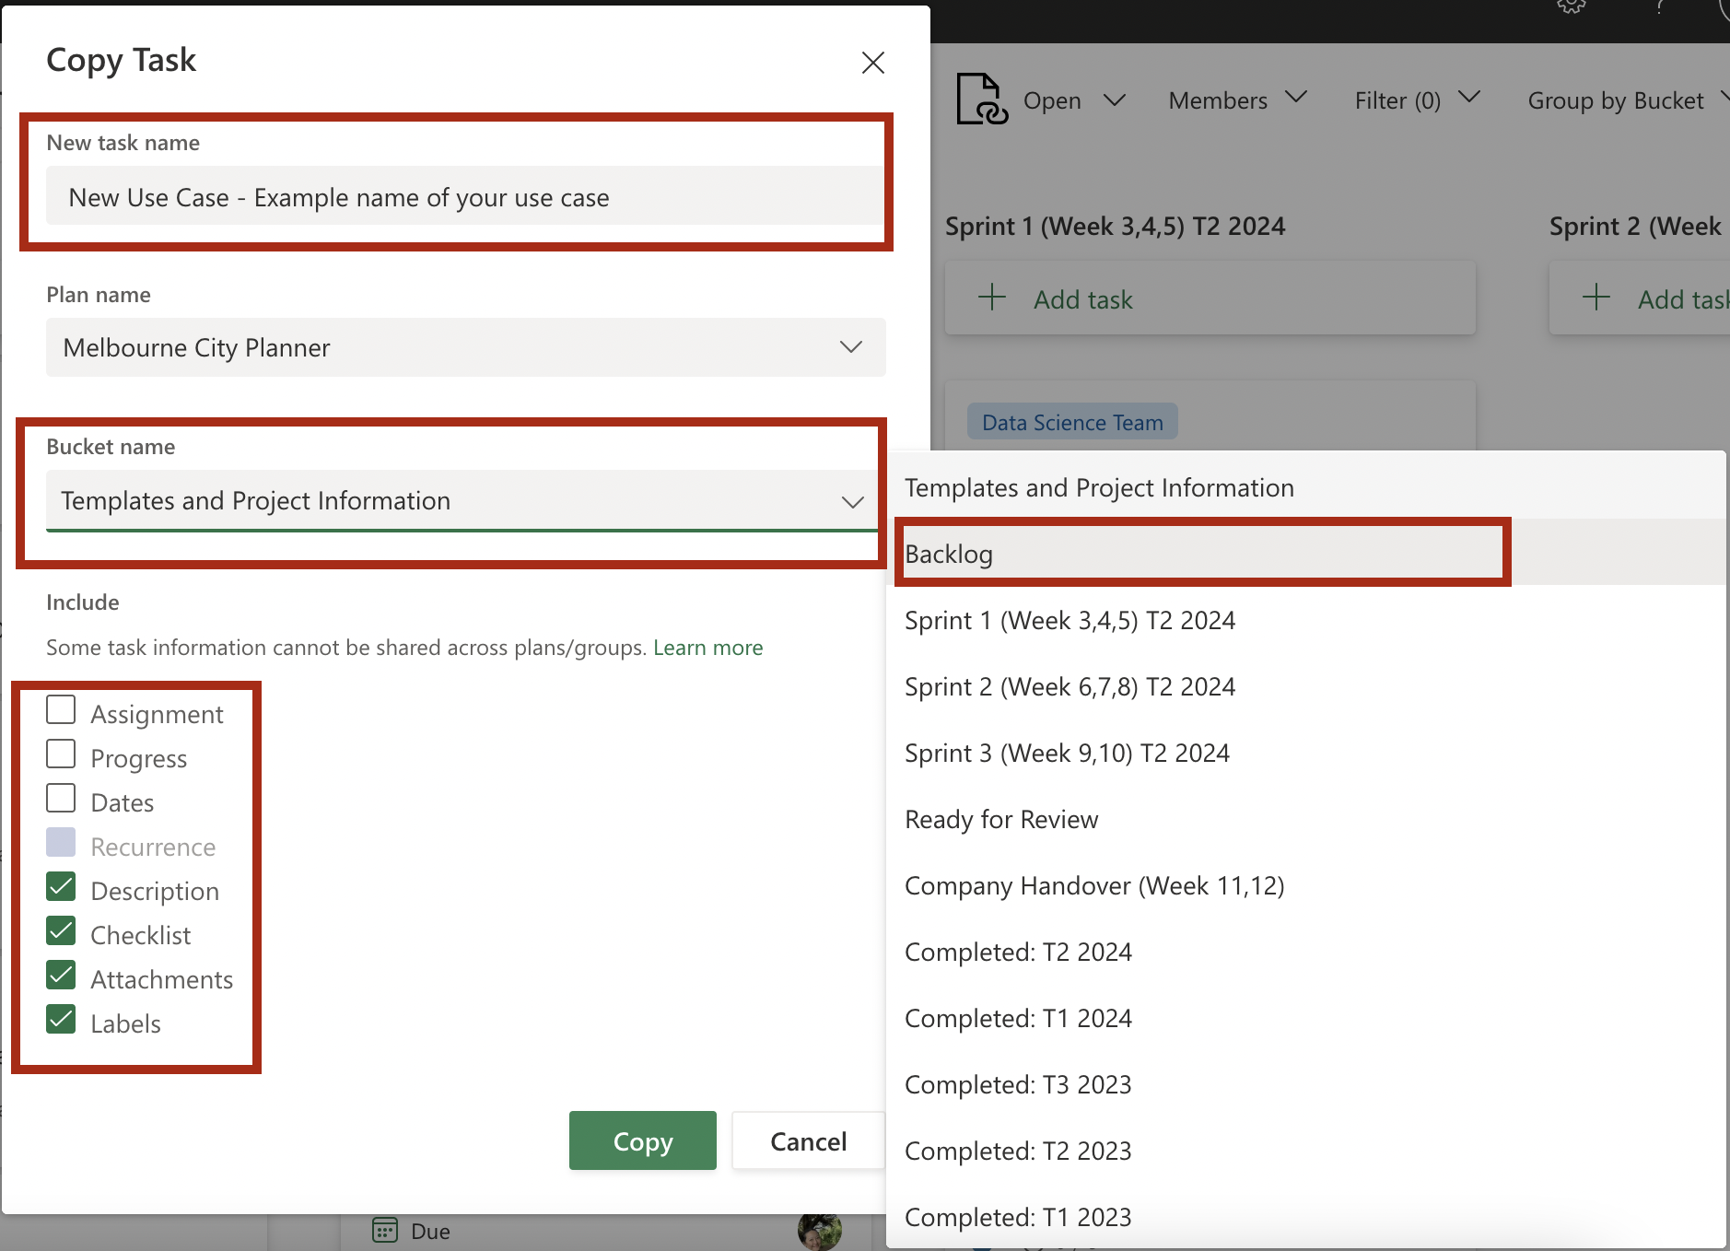

You can assign yourself by clicking the “Assign” button at the top left of the card and typing your name. To assign other members, click the “Assign” button again and type their names.

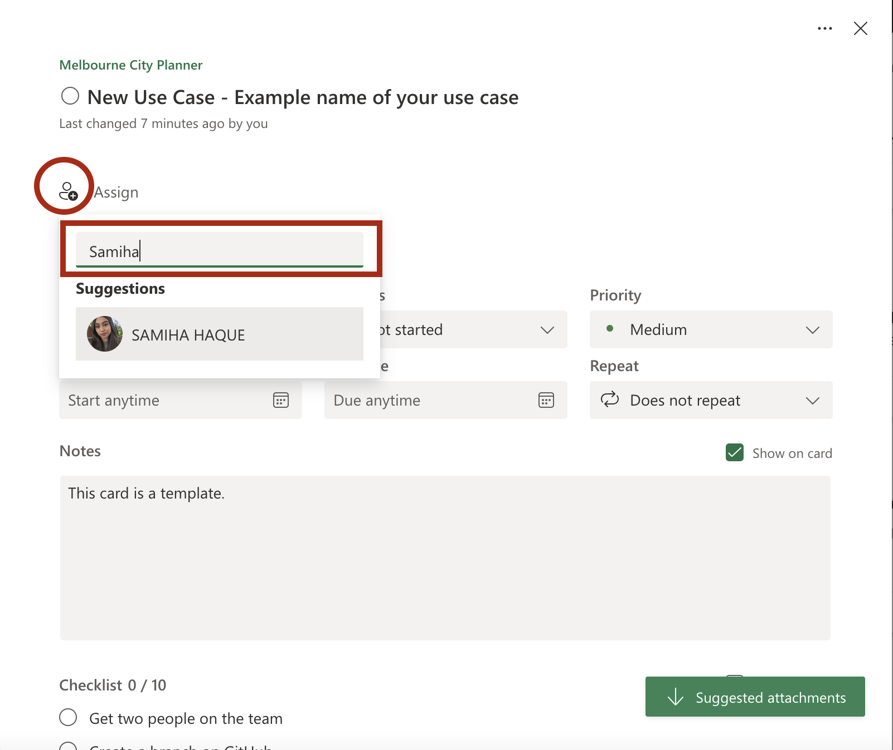

For Data Science Use Case cards, **the label must be light blue with the name “Data Science”**.

If you selected "Checklist" while copying this task, you should have a default checklist of 10 items to guide the progress of your use case. Feel free to modify these items according to your specific use case needs. ***MS Planner cards currently cannot have more than 20 checklists.***

In the notes section below, your use case card must have the following:

* + **Focus area**: It can be either Environment, Wellbeing, Transport and Safety, or Business Activity.
  + **Goal or Description**: A detailed explanation of the use case.
  + **Dataset Links**: URLs or references to relevant datasets.

*You can select the “Show on card” option to display details from outside, but this might make the card look lengthy. It is advisable to avoid this for now.*

|  |  |
| --- | --- |

* In the Attachments section, click “Add attachment” and choose from the three available options to attach your files. For example, select “A link to a URL.” Paste your link into the “Address” field and label it appropriately: use “GitHub Branch-1” for your first GitHub branch link, “GitHub Commit-1” for your first commit link, or “GitHub Pull Request-1” for your first pull request link and click “Save”. Adding these labels helps maintain a clear sequence and makes it easier for you and others to understand the order of multiple attachments. You can also have other files or GitHub links in your attachments. ***MS Planner cards currently cannot have more than 15 attachments.***

|  |  |
| --- | --- |

# There is another simple guideline towards creating a card on Planner here: [How to Create and Manage Cards on Planner](https://github.com/Chameleon-company/MOP-Code/blob/master/datascience/documentation/How%20to%20Create%20and%20Manage%20Cards%20on%20Planner%20V1.pdf)

# How to move cards?

To move cards, long-press and hold the card, then drag it across different buckets. The recommended flow for a card is: “Backlog” -> “Sprints-1 (2/3)” -> “Ready for Review” -> “Completed.” Following this flow will help replicate Trello’s functionality and make card management more intuitive.

# Ready for Review vs Completed buckets

Whenever your use case has a Pull Request on GitHub, move your card to the “Ready for Review” bucket. After the review is completed, move the card back to the appropriate Sprint or “Completed” bucket. If your use case is completed, drag your card to the “Completed” bucket. If the use case is not finished by the end of the trimester, place the card back in the “Backlog” so it can be picked up by you or another team member in the next trimester. ***Avoid clicking “Completed” in the “Progress” section, as this will make the card disappear and move the card to a separate section making it harder to view.***

# Creating other cards from scratch

In order to create cards for other purposes, you can move to “Templates and Project Information bucket” and select any of the template cards and click the three dots on the upper right side of the card and select "Copy Task". A pop up of the new card will allow you to rename the card, select the Planner, select the bucket.In the “Include” section, you can uncheck any boxes that you do not need, then proceed to create your new card.

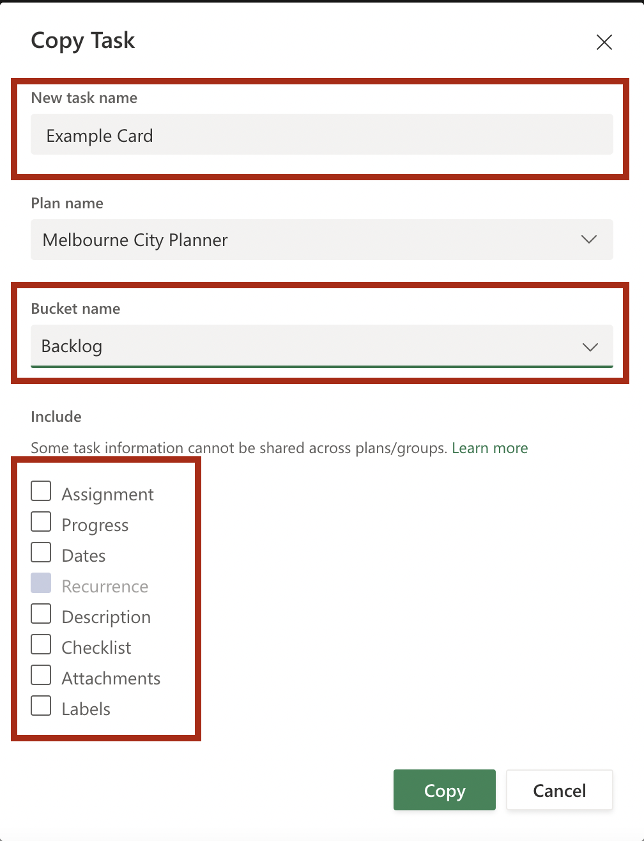

You can assign yourself to the card and click “Add label” to select the color and the label type from the dropdown. You can also make your own label by clicking the “pen” symbol to edit the name of labels.

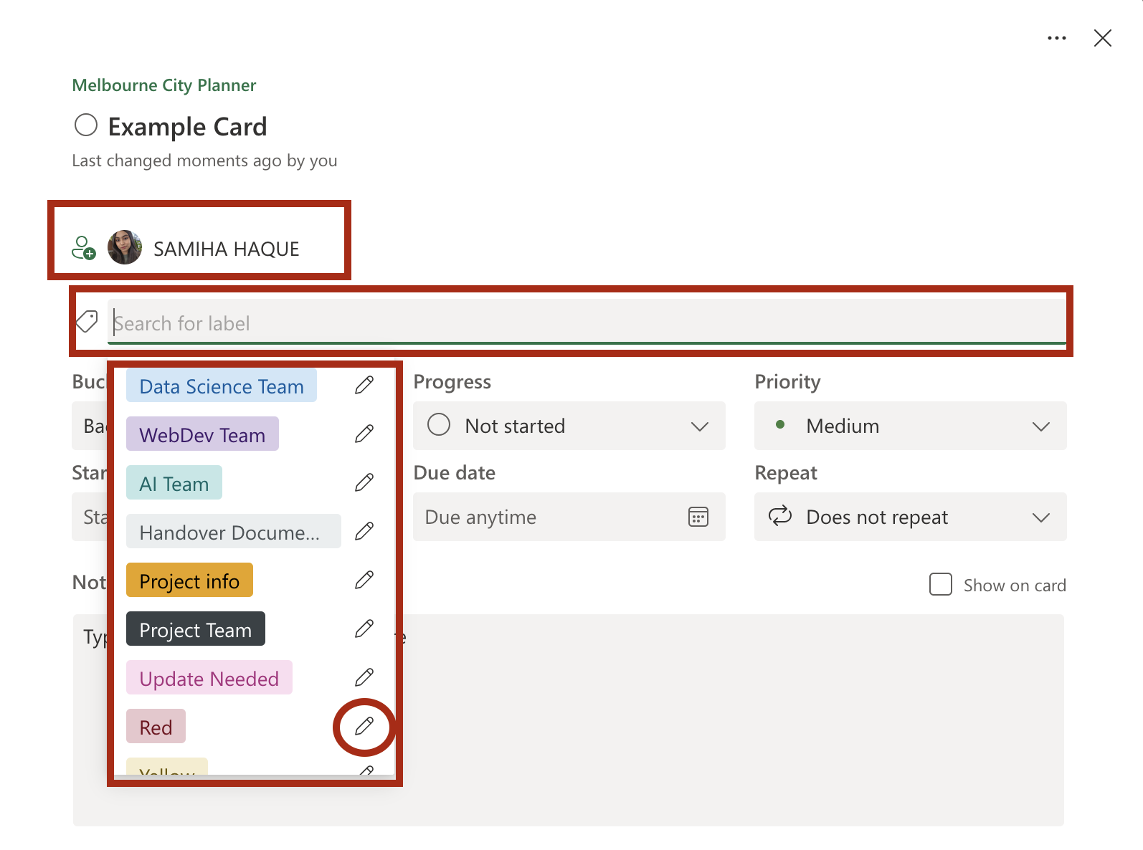

You can enter your relevant description in the “Notes” section and create your own checklist at the bottom by typing in “Add an item.” Additionally, include any necessary attachments if required.

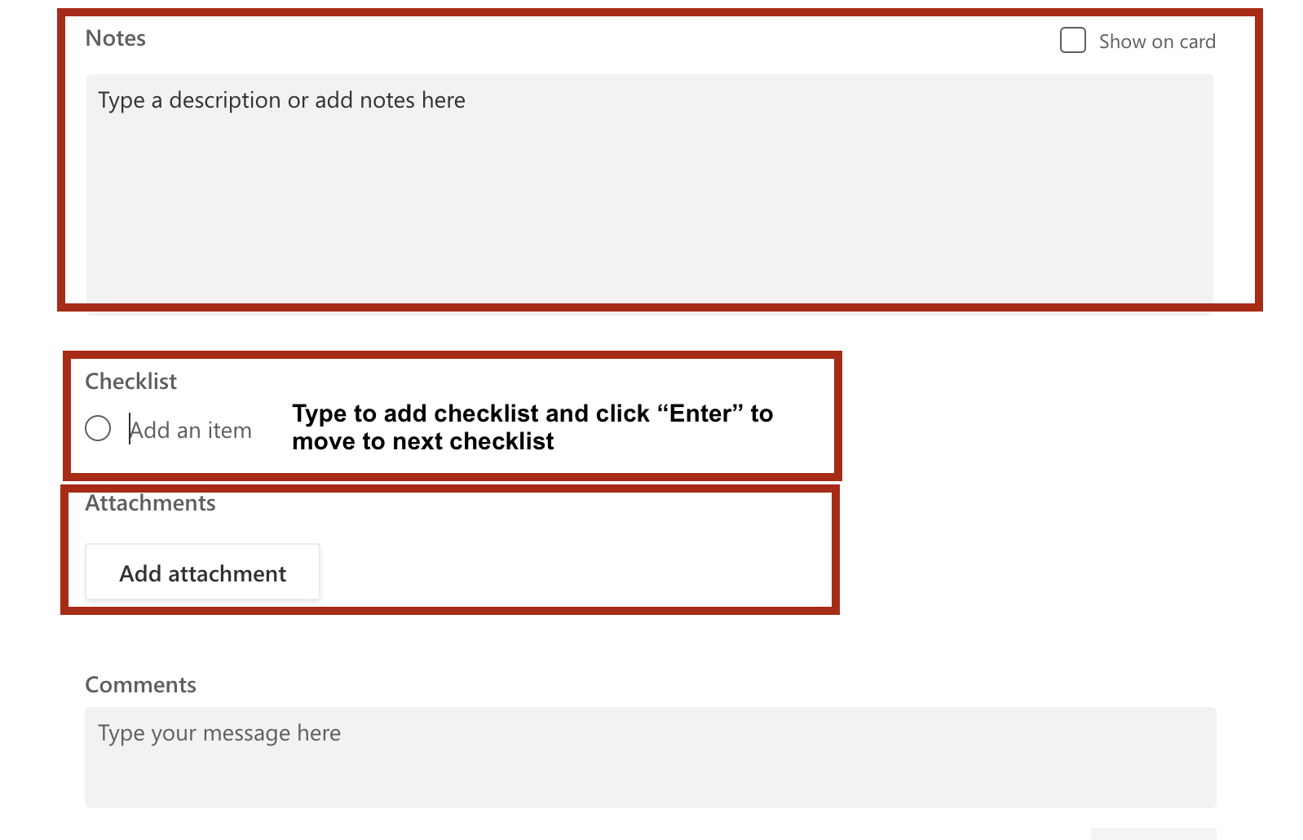

At the bottom of a card, you will find a comment section where you can include more details. Note that tagging members using @ is not supported by MS Planner at the moment, and commenting on someone else's card will not send them any notification.

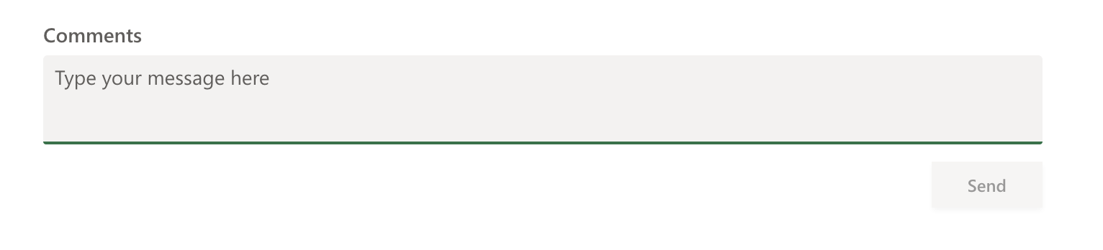

## Author

Samiha Haque 2024.v1